📊 Customer Shopping Behavior Analysis

End-to-End Retail Analytics Project1. Business Problem
Modern retail businesses generate large volumes of transactional data but often fail to convert that data into actionable insights.
The core challenges addressed in this project:
- Which product categories generate the highest revenue?
- Do subscription customers contribute more revenue?
- How does purchase frequency influence spending?
- What demographic segments drive sales?
- How can customer behavior inform marketing strategies?
The objective is to transform raw customer transaction data into strategic business intelligence.

2. Project Objective
To build a complete analytics pipeline that:
- Cleans and prepares raw retail data
- Stores structured data in a relational database
- Performs SQL-based business analysis
- Visualizes insights through an interactive Power BI dashboard
- Generates actionable business recommendations
- → Data Cleaning (Python)
→ Exploratory Data Analysis (EDA)
→ Feature Engineering
→ PostgreSQL Integration
→ SQL Analysis
→ Power BI Dashboard
→ Business Recommendations

3. Dataset Overview
- 3,900 customer transaction records
- 18 attributes (demographic, transactional, behavioral)
- Mixed categorical and numerical features

Data Categories

Customer Demographics
- Age
- Gender
- Location
Purchase Information
- Item Purchased
- Category
- Purchase Amount
- Season
- Shipping Type
Behavioral Indicators
- Previous Purchases
- Frequency of Purchases
- Subscription Status
Customer Experience
- Review Rating
- Discount Applied

4. Data Preprocessing (Python – Pandas)

4.1 Missing Value Handling
- 37 missing values detected in review_rating
- Imputed using median rating per product category
Rationale:
Median reduces distortion caused by extreme values and preserves category-level behavior.

4.2 Data Standardization
- Converted column names to snake_case
- Removed redundant columns (promo_code_used)
- Verified data consistency

4.3 Exploratory Data Analysis (EDA)
This is where analytical thinking was applied.

4.1 Data Structure Analysis
- 5 numerical columns
- 13 categorical columns
- 37 missing values in review_rating
Confirmed:
- No duplicate rows
- No major structural anomalies

4.2 Descriptive Statistics

Purchase Amount
- Mean ≈ 59.76 USD
- Min = 20
- Max = 100
Observation:
Purchase values are capped, indicating synthetic or controlled data.

Age Distribution
- Range: 18 – 70
- Median ≈ 44
Insight:
Customer base is evenly distributed across adult age groups.

4.3 Category Distribution
Clothing category has the highest frequency of purchases.
Business implication:
Core revenue driver likely tied to clothing products.

4.4 Gender Analysis
- Majority customers are male
- Revenue distribution analyzed by gender
Insight:
Gender-based marketing segmentation opportunity.

4.5 Subscription Analysis
Compared:
- Average purchase amount
- Previous purchases
- Frequency of purchases
Insight:
Subscription customers show more consistent engagement.

4.6 Correlation Analysis (Numerical Features)
Examined relationships between:
- Purchase Amount
- Previous Purchases
- Review Rating
- Age
Key Insight:
Higher previous purchases moderately correlate with higher spending.
This indicates strong potential for loyalty programs.

4.7 Feature Engineering

Age Segmentation
Created age_group column to analyze demographic contribution.

Purchase Frequency (Numeric Conversion)
Mapped categorical frequency into numeric days for quantitative analysis.
Example:
- Weekly → 7
- Monthly → 30
- Quarterly → 90
This enabled deeper behavioral modeling.

5. Database Integration (PostgreSQL)
To simulate a real-world data pipeline:
- Connected Python to PostgreSQL using SQLAlchemy
- Loaded cleaned dataset into database table customer
- Enabled structured querying using SQL
This step reflects real enterprise-level data architecture.

6. SQL Business Analysis
Key analytical queries performed:

Revenue by Category
Identified top revenue-generating product categories.

Subscription Impact Analysis
Compared:
- Average purchase amount
- Purchase frequency
- Previous purchases
between subscription and non-subscription customers.

Gender-Based Revenue
Analyzed spending distribution by gender.

Payment Method Trends
Identified most commonly used payment channels.

7. Power BI Dashboard
An interactive dashboard was developed to visualize insights.

Key Performance Indicators (KPIs)
- Total Revenue
- Average Purchase Amount
- Total Customers
- Average Review Rating
- Subscription Distribution

Visual Analysis
- Revenue by Category
- Revenue by Gender
- Seasonal Trends
- Age Group Contribution
- Purchase Frequency Distribution
- Payment Method Usage
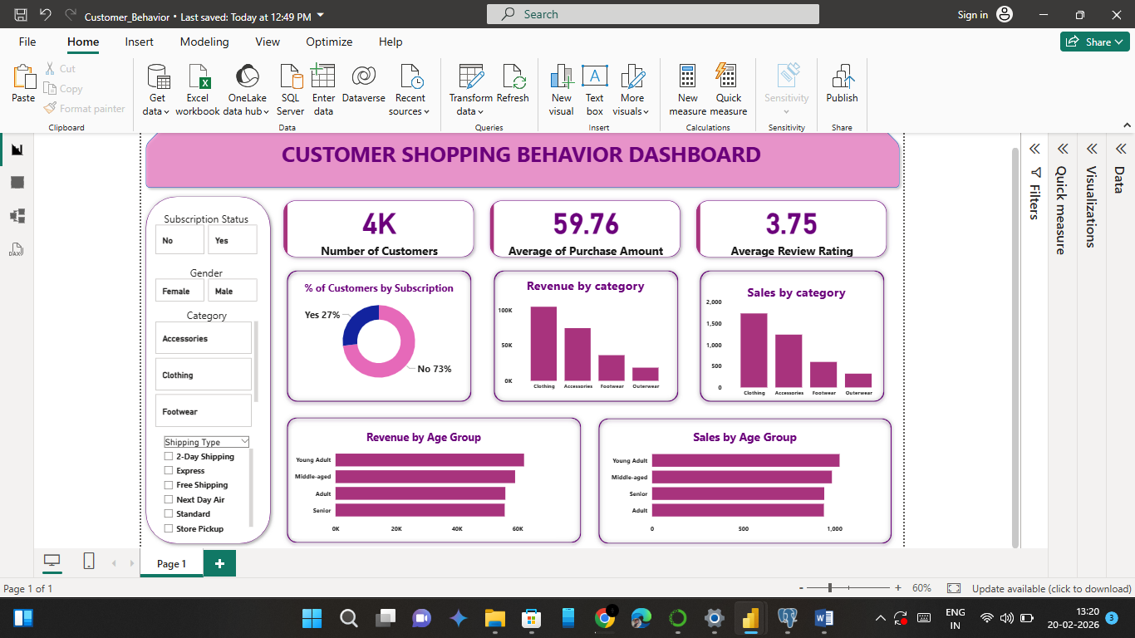
The dashboard enables business users to explore patterns dynamically.

8. Key Findings
- Certain product categories significantly outperform others in revenue generation.
- Subscription customers show consistent purchasing behavior.
- Higher purchase frequency correlates with higher spending.
- Seasonal patterns influence category performance.
- Digital payment methods dominate transaction volume.

9. Business Recommendations
Based on analysis:
- Expand subscription incentives to increase recurring revenue.
- Target high-frequency customers with loyalty programs.
- Optimize seasonal promotions by category performance.
- Personalize campaigns using age-group segmentation.
- Strengthen digital payment integration strategies.

10. Technical Skills Demonstrated
- Data Cleaning (Pandas)
- Exploratory Data Analysis
- Feature Engineering
- SQL Query Development
- Database Integration (PostgreSQL)
- Data Visualization (Power BI)
- Business Insight Generation
- End-to-End Data Pipeline Design

11. Project Architecture
CSV Dataset
↓
Python (Cleaning + Feature Engineering)
↓
PostgreSQL Database
↓
SQL Analysis
↓
Power BI Dashboard
↓
Business Insights & Recommendations

